**PROJECT TITLE – OPTIMIZING ENERGY DEMAND AND CONSUMPTION THROUGH DATA-DRIVEN STRATEGIES**

**PHASE – I**

**ABSTRACT:**

This project explores the optimization through data-driven strategies. Leveraging advanced analytics and machine learning, it examines the relationship between energy consumption patterns, environmental factors, and operational variables. The research investigates the various data sources, including historical consumption data, weather patterns, occupancy trends, and building characteristics, to develop predictive models for energy demand. By harnessing the power of big data analytics, these models offer insights into consumption patterns and enables proactive management strategies.

Furthermore, the paper examines the implementation demand response programs and smart grid technologies to dynamically adjust energy usage in response to real-time conditions. Through the integration of IOT devices and sensors network, buildings and infrastructure can adapt their energy consumption in accordance with fluctuations in demand and availability of renewable resources. Moreover, the study explores the role of data analytics in optimizing energy distribution networks, identifying inefficiencies, and reducing losses during transmission and distribution. By analysing vast quantities of data, utilities can enhance grid reliability, minimize downtime, and improve overall system efficiency.

Overall, this paper underscores the transformative potential of data-driven strategies in optimizing energy demand and consumption. By harnessing the power of data analytics, stakeholders can achieve substantial energy savings, mitigate environmental impacts, and pave the way for a more sustainable energy future

**INTRODUCTION:**

In the face of growing concerns about energy sustainability and environmental impact, optimizing energy demand and consumption has become a critical endeavour. Traditional methods of energy management often fall short in effectively addressing the complexities of modern energy systems. However, the advent of data-driven strategies offers promising avenues for achieving significant improvements in energy efficiency, cost savings, and environmental sustainability. This introduction sets the stage for exploring how leveraging data analytics techniques can revolutionize energy management practices, leading to more efficient allocation of resources and reduced carbon footprint.

The concept of optimizing energy demand and consumption through data-driven strategies entails harnessing the power of data analytics to gain insights into energy usage patterns, identify opportunities for efficiency gains, and inform decision-making processes. By analysing vast amounts of data collected from various sources, including historical energy consumption data, weather patterns, building characteristics, and socio-economic factors, organizations can uncover hidden patterns and correlations that enable them to develop tailored solutions to manage energy demand effectively. This introduction provides a framework for understanding the multifaceted approach required to tackle energy optimization challenges and highlights the potential benefits of embracing data-driven methodologies in the pursuit of a more sustainable energy future.

**METHODOLOGY:**

**DATA ACQUISITION AND PREPARATION:**

Data Acquisition:

* Accurate and uninterrupted data acquisition is essential. It should be done in a non-intrusive and cost-efficient manner.
* However, data richness alone doesn’t provide useful insights. We need to transform this data into meaningful information.

Data Preparation:

* Once acquired, data needs to be prepared for analysis. This involves cleaning, structuring, and organizing the data.
* Feature engineering is crucial. Extract relevant features from raw data to create informative variables for modelling.

**MODEL SELECTION AND TRAINING:**

Model Selection:

* Regression Models: Linear regression, polynomial regression, and regression tree-based models (e.g., decision trees, random forests) are commonly used for predicting energy consumption based on historical data and relevant features.
* Time Series Forecasting: For forecasting energy demand over time, models such as autoregressive integrated moving average (ARIMA), seasonal decomposition of time series (STL), or recurrent neural networks (RNNs) like Long Short-Term Memory (LSTM) networks are effective.
* Classification Models: Support Vector Machines (SVM), k-Nearest Neighbours (k-NN), and neural networks can be used for classifying energy demand patterns or identifying energy-intensive equipment malfunctions.

Model Training and Validation:

* Split the dataset into training, validation, and testing sets. Use cross-validation techniques (e.g., k-fold cross-validation) to assess model performance and reduce overfitting.
* Train the selected models on the training data using appropriate algorithms and hyperparameters.
* Validate model performance on the validation set and iteratively refine models based on validation results.

**DATA EXPLORATION (DATA VISUALIZATION & DATA ANALYSIS):**

Data Visualization:

* Use time series graphs to detect trends and seasonality in energy consumption.
* Employ histograms and distribution plots to assess data distribution and identify outliers.
* Construct correlation heatmaps and scatter plots to understand relationships between energy consumption and related variables.

Data Analysis:

* Calculate descriptive statistics to summarize energy consumption data.
* Decompose time series to identify seasonal patterns and long-term trends.
* Apply cluster analysis and PCA to uncover consumption patterns and reduce dimensionality.

**DASHBOARD CREATION:**

* Clearly outline the goals of your energy optimization efforts. Determine what metrics you want to track and improve, such as energy usage, cost savings, or carbon footprint reduction.
* Gather data from various sources such as smart meters, IoT sensors, weather forecasts, historical usage data, and building management systems.
* Sketch out the layout of your dashboard, including key performance indicators (KPIs), charts, graphs, and tables.
* Test the dashboard with stakeholders to gather feedback and identify areas for improvement.
* Deploy the dashboard to production environment and ensure ongoing maintenance and updates to refine the dashboard over time.

**WEBPAGE CREATION & DATABASE CONNECTIONS USING (DJANGO OR FLASK):**

* Install Flask.
* Create a new directory for your Flask project and navigate into it.
* Create a Python File, Inside the project directory, create a Python file named “app.py”
* Define Data Models, Define your data models directly within the `app.py` file.
* Create HTML Templates
* Initialize Database
* Run the Flask Application
* Access the Dashboard
* Open a web browser and navigate to ‘http://127.0.0.1:5000/’ to access the energy consumption dashboard.

**EVALUATION:**

* Reduction in energy consumption and peak demand.
* Cost savings achieved through energy efficiency improvements.
* Environmental benefits such as reduced carbon emissions.
* Evaluated the impact of optimization efforts by measuring key performance indicators such as energy savings, cost reductions, and environmental benefits.

**WORK FLOW DIAGRAM:**



**EXISTING WORK:**

* Smart Grid Technologies: Smart grid technologies integrate advanced sensing, communication, and control capabilities to optimize energy distribution and consumption.
* Demand Response Programs: Demand response programs incentivize consumers to adjust their energy usage in response to supply conditions or price signals.
* Optimization Algorithms: Researchers have developed optimization algorithms specifically tailored for energy demand and consumption management.
* Government Initiatives: Governments and regulatory bodies around the world are increasingly focusing on energy efficiency and sustainability goals.

**PROPOSED WORK:**

* A proposed work on optimizing energy demand and consumption through data-driven strategies would likely involve developing and implementing methods to better manage and reduce energy usage in various contexts, such as buildings, industrial processes, or transportation systems.
* Overall, a project focused on optimizing energy demand and consumption through data-driven strategies would aim to leverage data analytics and technology to achieve greater efficiency, reduce costs, and minimize environmental impact in energy-intensive systems and processes.

**SOFTWARE REQUIREMENTS:**

1.IBM Cognos analytics tool:

https://www.ibm.com/products/cognos-analytics

2.Visual Studio:

https://code.visualstudio.com/

3.Flask:

Flask Documentation (3.0.x) (palletsprojects.com)

4.Python Libraries:

* NumPy: https://numpy.org/
* Pandas: https://pandas.pydata.org/
* Scikit: https://scikit-learn.org/
* Seaborn: https://seaborn.pydata.org/
* Matplotlib: https://matplotlib.org/
* Stats models: https://www.statsmodels.org/

**FUTURE WORK:**

* Future work on optimizing energy demand and consumption through data-driven strategies could explore several important avenues to advance the field.
* Investigate the application of advanced machine learning algorithms, such as deep learning and reinforcement learning, to optimize energy demand prediction and consumption patterns. (Important work: "Deep Learning for Time Series Forecasting: Predicting Energy Consumption" by Zhang, X. et al.)
* Investigate data-driven approaches to optimize the operation and control of smart grid components, such as microgrids and distribution automation systems, to improve energy efficiency and reliability.

**CONCLUSION:**

In conclusion, optimizing energy demand and consumption through data-drive strategies represents a crucial pathway towards achieving greater efficiency, sustainability, and resilience in our energy systems. By harnessing the power of data analytics, machine learning, and predictive modelling, researchers and practitioners can develop innovative solutions to address the complex challenges of energy management.

Key works in this field highlight the importance of advanced data analytics techniques, integration of renewable energy sources, smart grid technologies, behavioural analytics, and policy frameworks. These important works provide valuable insights and methodologies for advancing the field and driving impactful changes in energy consumption patterns.

**PHASE – II**

**DATA COLLECTION AND PRE-PROCESSING:**

**1.DATA ACQUISITION AND PREPARATION:**

Data Collection Methods:

An Optimizing energy demand and consumption dataset typically includes information about energy consumption data, weather data, sensors networked data, Historical Data. It's invaluable for understanding energy demand and consumption, preferences, and predicting future actions. The energy consumption data was collected from the open source through Kaggle-dataset website.

Link:

https://www.kaggle.com/datasets/nasirayub2/electricityload-logistics-iot

**2.DATA MODULE CONVERSION:**

Data cleaning:

Data cleaning involves identifying and correcting errors or inconsistencies in a dataset to improve its quality and reliability for analysis. Common tasks include removing duplicates, handling missing values, outlier detection and removal and standardizing formats.

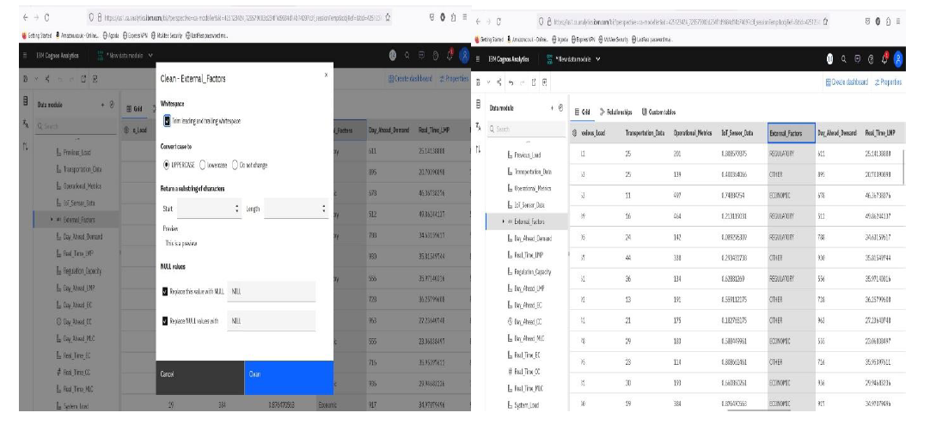

Data Integration:

Data integration merges data from multiple sources into a unified view, enabling comprehensive analysis and decision-making. It involves transforming, mapping, and reconciling data to ensure consistency.



Data Transformation:

Data transformation involves converting data from one format, structure, or representation to another to suit analytical requirements or integration purposes.



**3. DATA EXPLORATION (Data Visualization and Data Analysis):**

Data Visualization:

Data visualization is the graphical representation of data to uncover insights and communicate findings effectively. Types include charts, graphs, maps, and dashboards, each tailored to display specific patterns or relationships in the data.

Anomaly Detection:

Anomaly detection is the process of identifying data points, events, or patterns that deviate significantly from the norm, potentially indicating errors, outliers, or suspicious activity.

Screenshots:

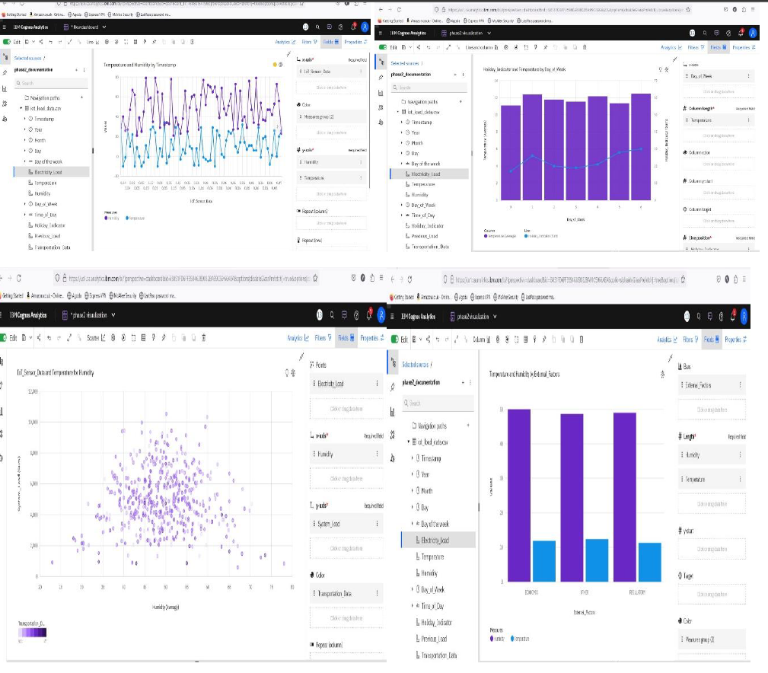

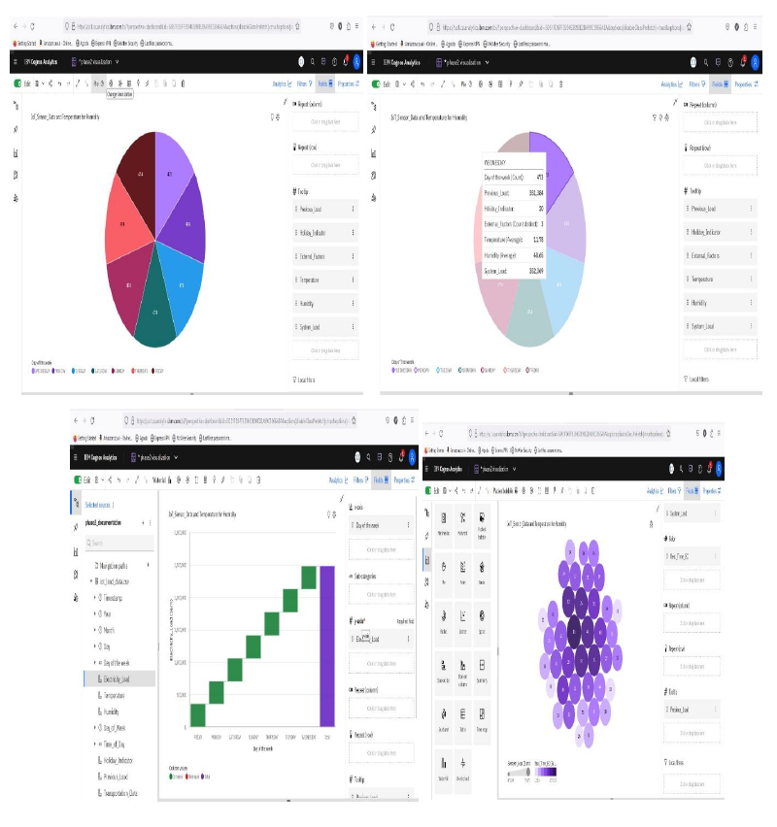

**PHASE – III**

**DASHBOARD CREATION:**

**LINKS:**

1. **INTRO_PAGE:** https://us1.ca.analytics.ibm.com/bi/?perspective=dashboard&pathRef=.my_folders%@FMY&action=view&mode=dashboard&subView=model0000018f8ce421ce_00000000
2. **DAY_OF_THE_WEEK:** https://us1.ca.analytics.ibm.com/bi/?perspective=dashboard&pathRef=.my_folders%@FMY&action=view&mode=dashboard&subView=model0000018f8f5942f4_00000000
3. **TIME_OF_THE_DAY:** https://us1.ca.analytics.ibm.com/bi/?perspective=dashboard&pathRef=.my_folders%@FMY&action=view&mode=dashboard&subView=model0000018f8f788389_00000000
4. **EXTERNAL_FACTOR:** https://us1.ca.analytics.ibm.com/bi/?perspective=dashboard&pathRef=.my_folders%@FMY&action=view&mode=dashboard&subView=model0000018f8fb2319b_00000000

**DASHBOARD SCREENSHOT & ANALYSIS:**

**INTRO PAGE SCREENSHOT:**



**IoT Sensor Data:**

* Day of Week 1 has the lowest total IoT Sensor Data at 233.63, followed by 4 at 236.71.
* Day of Week 3 has the highest total IoT Sensor Data at 247.27, followed by 0 at 246.94.
* Based on the current forecasting, IoT Sensor Data may reach 236.6 by Day of Week 8.
* The overall number of results for IoT Sensor Data is almost 3500.

**Day Ahead Demand:**

* Day_of_Week 4 has the lowest total Day_Ahead_Demand at over 353 thousand, followed by 5 at almost 354 thousand.
* Day_of_Week 3 has the highest total Day_Ahead_Demand at over 357 thousand, followed by 2 at nearly 357 thousand.
* Based on the current forecasting, Day_Ahead_Demand may reach nearly 355 thousand by Day_of_Week 8.
* The overall number of results for Day_Ahead_Demand is almost 3500.

**Electricity Load:**

* Day_of_Week 0 has the lowest total Electricity_Load at over 346 thousand, followed by 2 at over 351 thousand.
* Day_of_Week 3 has the highest total Electricity_Load at over 359 thousand, followed by 1 at over 357 thousand.
* Based on the current forecasting, Electricity_Load may reach nearly 359 thousand by Day_of_Week 8.
* The overall number of results for Electricity_Load is almost 3500.

**DAY OF THE WEEK SCREENSHOT:**

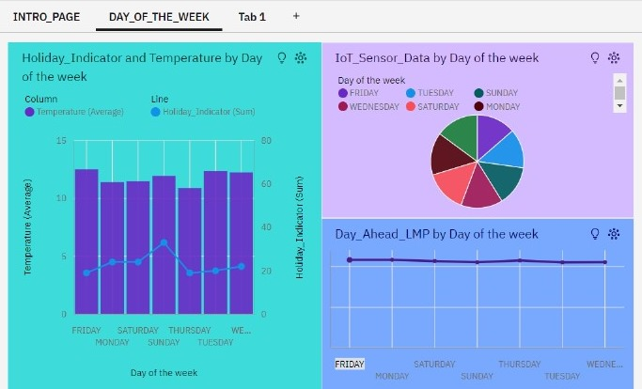

**Holiday Indicator and Temperature:**

* Day of the week FRIDAY has the highest Average Temperature but is ranked #6 in Average Humidity.
* Day of the week TUESDAY has the highest Average Humidity but is ranked #2 in Average Temperature.
* Overall day of the weeks, the average of Temperature is 11.83.
* The average values of Temperature range from 10.88, occurring when Day of the week is THURSDAY, to 12.5, when Day of the week is FRIDAY.
* Day of the week FRIDAY has the highest Average Temperature but is ranked #6 in Total Holiday Indicator.

**IoT Sensor Data:**

* Day of the week THURSDAY has the highest Total IoT_Sensor_Data but is ranked #7 in Average Humidity.
* Day of the week TUESDAY has the highest Average Humidity but is ranked #6 in Total IoT_Sensor_Data.
* Overall day of the weeks, the average of IoT_Sensor_Data is 0.5097.
* The total number of results for IoT_Sensor_Data, across all day of the weeks, is almost 3500.

**Day Ahead LMP:**

* Day of the week TUESDAY has the highest Average Humidity but is ranked #7 in Total Day_Ahead_LMP.
* Day of the week MONDAY has the highest Total Day_Ahead_LMP but is ranked #5 in Average Humidity.
* Day_Ahead_LMP ranges from over 21 thousand, when Day of the week is TUESDAY, to almost 22 thousand, when Day of the week is MONDAY.

**TIME_OF_THE_DAY SCREENSHOT:**

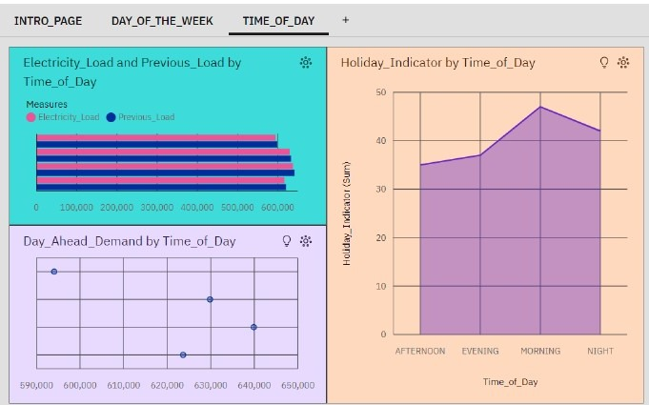

**Holiday Indicator:**

* Time_of_Day MORNING has the highest values of both Holiday Indicator and Temperature.
* Holiday Indicator ranges from 35, when Time_of_Day is AFTERNOON, to 47, when Time_of_Day is MORNING.
* For Holiday Indicator, the most significant values of Time_of_Day are MORNING and NIGHT, whose respective Holiday Indicator values add up to 89, or 55.3 % of the total.
* Over all values of Time_of_Day, the sum of Holiday Indicator is 161

**Day Ahead Demand:**

* Time_of_Day AFTERNOON has the highest Average Humidity but is ranked #4 in Total Day_Ahead_Demand.
* Time_of_Day MORNING has the highest Total Day_Ahead_Demand but is ranked #4 in Average Humidity.
* The total number of results for Day_Ahead_Demand, across all Day_Ahead_Demand, is 4.
* The total number of results for Time_of_Day, across all Day_Ahead_Demand, is 4.

**Electricity Load and Previous Load:**

* Time_of_Day MORNING has the highest values of both Electricity_Load and Previous Load.
* Over all values of Time_of_Day, the average of Electricity_Load is 747.1.
* Over all values of Time_of_Day, the average of Previous Load is 751.7.
* The total number of results for Electricity Load, Previous Load across all Time_of_Day, is almost 3500.

**EXTERNAL FACTORS SCREENSHOT:**

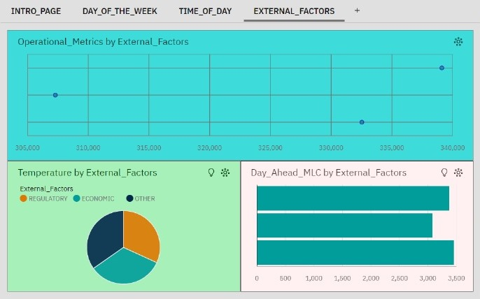

**Operational Metrics:**

* External Factors ECONOMIC has the highest values of both Operational Metrics and Humidity.
* The total number of results for External Factors, across all Operational Metrics, is 3.
* The total number of results for Operational Metrics, across all Operational Metrics, is 3.

**Temperature:**

* External Factors OTHER has the highest Average Temperature but is ranked #3 in Average Humidity.
* External Factors ECONOMIC has the highest Average Humidity but is ranked #2 in Average Temperature.
* REGULATORY (34.3 %) and ECONOMIC (34.2 %) are the most frequently occurring categories of External Factors with a combined count of 2,272 items with Temperature values (68.5 % of the total).
* Over all values of External Factors, the average of Temperature is 11.83.
* The average values of Temperature range from 11.31, occurring when External Factors is REGULATORY, to 12.33, when External Factors is OTHER.

**Day Ahead MLC:**

* Day_Ahead_MLC is unusually low when External Factors is OTHER.
* External Factors ECONOMIC has the highest Average Humidity but is ranked #2 in Total Day_Ahead_MLC.
* External Factors REGULATORY has the highest Total Day_Ahead_MLC but is ranked #2 in Average Humidity.
* Day_Ahead_MLC ranges from over three thousand, when External Factors is OTHER, to almost 3500, when External Factors is REGULATORY.

**CONCLUSION:**

In conclusion, the adoption of data-driven strategies for optimizing energy demand and consumption is a strategic necessity for organizations aiming for sustainability and efficiency. The insights provided by our dashboard demonstrate the transformative potential of data in driving smarter, more sustainable energy practices. Continuous innovation and investment in data analytics will be crucial for sustaining and enhancing these benefits, ensuring a resilient and energy-efficient future.

**PHASE – IV**

**PROJECT DESCRIPTION:**

**1. INTRODUCTION:**

This project aims to enhance energy efficiency and reduce operational costs by implementing data-driven strategies to optimize energy demand and consumption across residential, commercial, and industrial sectors.

**2. OBJECTIVES:**

1. **Data Collection:** Gather and integrate data from smart meters, IoT sensors, weather forecasts, and historical usage.
2. **Consumption Analysis:** Identify inefficiencies and anomalies in current energy use through advanced analytics.
3. **Predictive Modeling:** Forecast future energy demand using machine learning techniques.
4. **Optimization Strategies:** Develop algorithms to minimize energy use during peak hours and reduce costs.
5. **Real-Time Monitoring:** Implement systems for real-time tracking and automated control of energy usage.
6. **User Engagement:** Provide stakeholders with actionable insights via user-friendly interfaces and dashboards.
7. **Sustainability:** Align strategies with environmental goals and regulatory requirements.

**3. METHODOLOGY:**

1. **Data Acquisition**: Deploy IoT sensors and integrate external data sources.
2. **Data Processing:** Use cloud-based platforms for data storage and processing.
3. **Analytical Framework:** Apply statistical and machine learning techniques to analyze data.
4. **Model Development:** Build and validate predictive models for energy demand forecasting.
5. **Optimization Implementation:** Design and implement energy optimization algorithms.
6. **Visualization:** Create interactive dashboards and regular performance reports.

**4. EXPECTED OUTCOMES:**

1. **Energy Savings:** Reduced energy consumption and costs.
2. **Efficiency Gains:** Improved energy usage efficiency.
3. **Sustainability:** Better alignment with environmental goals.
4. **User Empowerment:** Increased user awareness and engagement.
5. **Scalability:** A scalable solution adaptable to various settings and technologies.

**5. CONCLUSION:**

The project seeks to create a more efficient, sustainable, and cost-effective energy management system through the use of advanced analytics, predictive modeling, and real-time optimization.

**DASHBOARD COMPLETION SCREENSHOTS & ANALYSIS:**



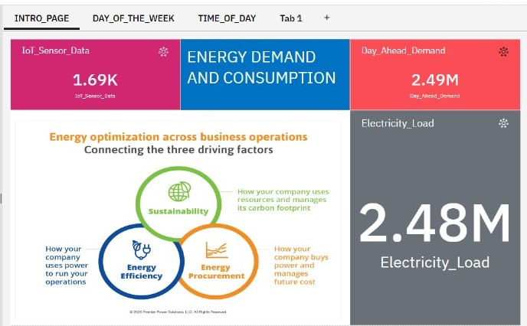





**ANALYSIS:**

* Day_of_Week 1 has the lowest total IoT_Sensor_Data at 233.63, followed by 4 at 236.71.
* Add insight to favorites
* Day_of_Week 3 has the highest total IoT_Sensor_Data at 247.27, followed by 0 at 246.94.
* Add insight to favorites
* Based on the current forecasting, IoT_Sensor_Data may reach 236.6 by Day_of_Week 8.
* The overall number of results for IoT_Sensor_Data is almost 3500.

**LINK:**

**INTRO_PAGE:**

[**https://us1.ca.analytics.ibm.com/bi/?perspective=dashboard&pathRef=.my_folders%2FMY&action=view&mode=dashboard&subView=model0000018f8ce421ce_00000000**](https://us1.ca.analytics.ibm.com/bi/?perspective=dashboard&pathRef=.my_folders%2FMY&action=view&mode=dashboard&subView=model0000018f8ce421ce_00000000)

**DAY_OF_THE_WEEK:**

[**https://us1.ca.analytics.ibm.com/bi/?perspective=dashboard&pathRef=.my_folders%2FMY&action=view&mode=dashboard&subView=model0000018f8f5942f4_00000000**](https://us1.ca.analytics.ibm.com/bi/?perspective=dashboard&pathRef=.my_folders%2FMY&action=view&mode=dashboard&subView=model0000018f8f5942f4_00000000)

**TIME_OF_DAY:**

[**https://us1.ca.analytics.ibm.com/bi/?perspective=dashboard&pathRef=.my_folders%2FMY&action=view&mode=dashboard&subView=model0000018f8f788389_00000000**](https://us1.ca.analytics.ibm.com/bi/?perspective=dashboard&pathRef=.my_folders%2FMY&action=view&mode=dashboard&subView=model0000018f8f788389_00000000)

**EXTERNAL_FACTORS:**

[**https://us1.ca.analytics.ibm.com/bi/?perspective=dashboard&pathRef=.my_folders%2FMY&action=view&mode=dashboard&subView=model0000018f8fb2319b_00000000**](https://us1.ca.analytics.ibm.com/bi/?perspective=dashboard&pathRef=.my_folders%2FMY&action=view&mode=dashboard&subView=model0000018f8fb2319b_00000000)

**REPORT COMPLETION SCREENSHOT & ANALYSIS:**

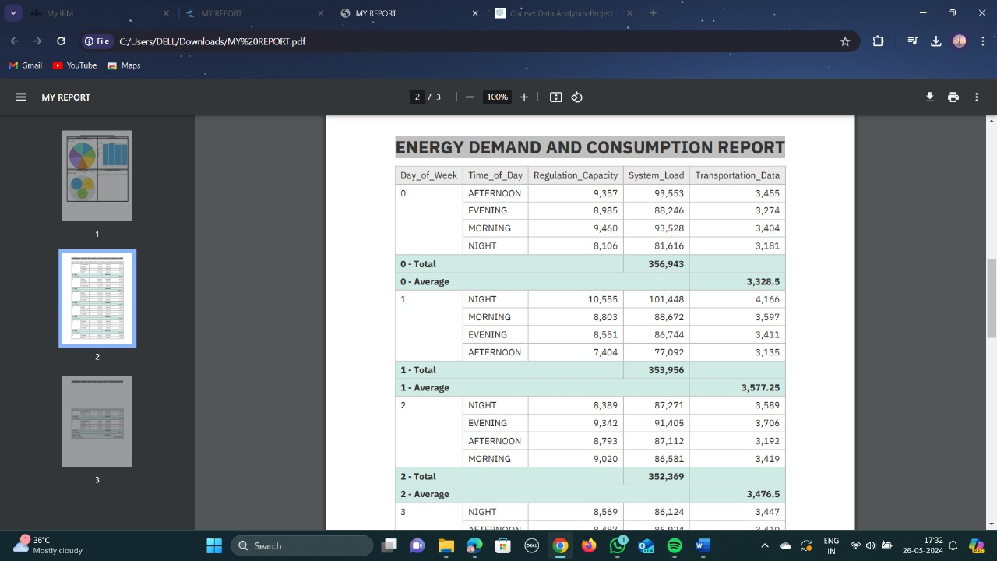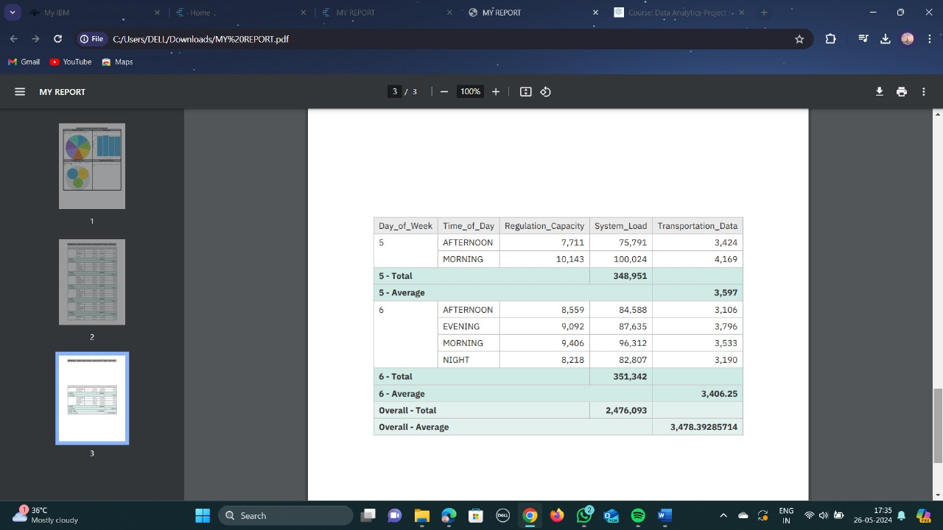

**LINK:**

[**https://us1.ca.analytics.ibm.com/bi/?pathRef=.my_folders%2FMY%2BREPORT&action=run&format=HTML&prompt=true**](https://us1.ca.analytics.ibm.com/bi/?pathRef=.my_folders%2FMY%2BREPORT&action=run&format=HTML&prompt=true)

**EXPLORATION COMPLETION SCREENSHOT & ANALYSIS:**

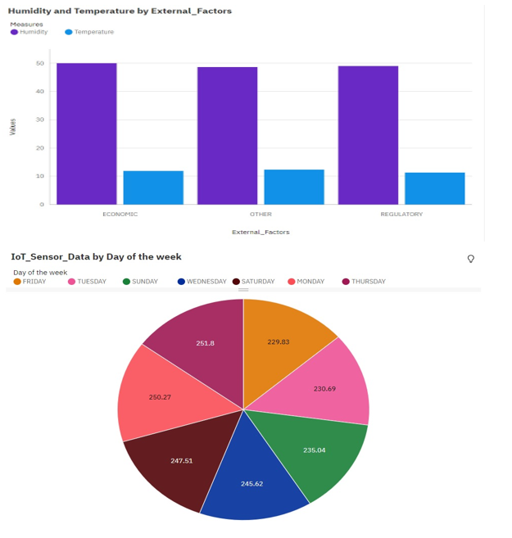

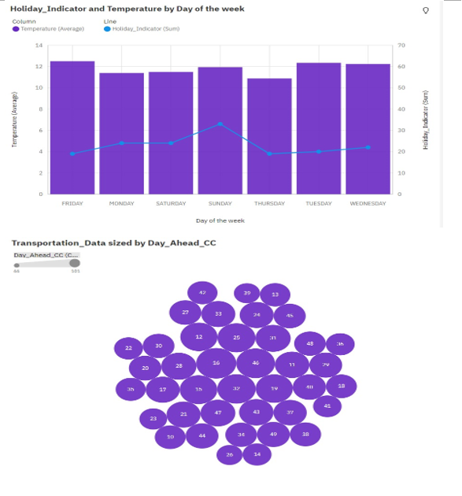

**ANALYSIS:**

* IoT_Sensor_Data ranges from 229.8, when Day of the week is FRIDAY, to 251.8, when Day of the week is THURSDAY.
* The total number of results for IoT_Sensor_Data, across all day of the weeks, is almost 3500.
* Over all day of the weeks, the average of IoT_Sensor_Data is 0.5097.
* MONDAY (14.3 %) and SUNDAY (14.3 %) are the most frequently occurring categories of Day of the week with a combined count of 950 items with IoT_Sensor_Data values (28.6 % of the total).

**LINK:**

1. [**https://us1.ca.analytics.ibm.com/bi/?perspective=explore&pathRef=.my_folders%2FMY%2BDATA%2BVISUALIZATION&subView=model0000018f8d0e0aa4_00000000**](https://us1.ca.analytics.ibm.com/bi/?perspective=explore&pathRef=.my_folders%2FMY%2BDATA%2BVISUALIZATION&subView=model0000018f8d0e0aa4_00000000)
2. [**https://us1.ca.analytics.ibm.com/bi/?perspective=explore&pathRef=.my_folders%2FMY%2BDATA%2BVISUALIZATION&subView=model0000018f8d0407b2_00000000**](https://us1.ca.analytics.ibm.com/bi/?perspective=explore&pathRef=.my_folders%2FMY%2BDATA%2BVISUALIZATION&subView=model0000018f8d0407b2_00000000)
3. [**https://us1.ca.analytics.ibm.com/bi/?perspective=explore&pathRef=.my_folders%2FMY%2BDATA%2BVISUALIZATION&subView=model0000018f8d070215_00000000**](https://us1.ca.analytics.ibm.com/bi/?perspective=explore&pathRef=.my_folders%2FMY%2BDATA%2BVISUALIZATION&subView=model0000018f8d070215_00000000)
4. [**https://us1.ca.analytics.ibm.com/bi/?perspective=explore&pathRef=.my_folders%2FMY%2BDATA%2BVISUALIZATION&subView=model0000018f8d15ada3_00000000**](https://us1.ca.analytics.ibm.com/bi/?perspective=explore&pathRef=.my_folders%2FMY%2BDATA%2BVISUALIZATION&subView=model0000018f8d15ada3_00000000)

**SAMPLE SCREENSHOTS OF WEB PAGE TO BE BUILT:**



**PHASE – V**

**TABLES OF CONTENTS:**

1. Abstract

2. Introduction

3. Methodology

4. Existing Work

5. Proposed Work

6. System Requirements

* Software Components

7. Implementation Details

* Work Flow Diagram

8. Data Collection and Pre-processing

* Data acquisition & preparation
* Data Module conversion

9. Data Exploration (Data Visualization & Analysis)

10. Dashboard Creation

11. Report Creation

12. Story Creation

13. Descriptive Analysis

14. Predictive Analysis

15. Action plan

16. Conclusion

**1. ABSTRACT:**

This project explores the application of data-driven strategies to optimize energy demand and consumption across various sectors. Through a structured approach encompassing data collection, analysis, implementation, and evaluation, the project aims to address the challenges associated with peak demand management, energy efficiency enhancement, and integration of renewable energy sources. By leveraging advanced data analytics techniques, including statistical analysis, machine learning, and predictive modelling, insights are extracted from historical energy usage data, weather patterns, building characteristics, and other relevant factors. The implementation phase involves the deployment of demand response programs, energy efficiency measures, renewable energy integration, and behavioural change campaigns. Continuous monitoring and feedback mechanisms facilitate iterative improvement, ensuring that strategies are fine-tuned for maximum effectiveness. The project's outcomes are evaluated against predefined goals, with a focus on cost savings, environmental impact reduction, and sustainability enhancement. Through documentation of best practices and scalability considerations, the project aims to provide actionable insights for stakeholders seeking to replicate and scale successful energy optimization initiatives.

**2. INTRODUCTION:**

In the face of growing concerns about energy sustainability and environmental impact, optimizing energy demand and consumption has become a critical endeavour. However, the advent of data-driven strategies offers promising avenues for achieving significant improvements in energy efficiency, cost savings, and environmental sustainability. This introduction sets the stage for exploring how leveraging data analytics techniques can revolutionize energy management practices, leading to more efficient allocation of resources and reduced carbon footprint. The concept of optimizing energy demand and consumption through data-driven strategies entails harnessing the power of data analytics to gain insights into energy usage patterns, identify opportunities for efficiency gains, and inform

decision-making processes. By analysing vast amounts of data collected from various sources, including historical energy consumption data, weather patterns, building characteristics, and socio-economic factors, organizations can uncover hidden patterns and correlations that enable them to develop tailored solutions to manage energy demand effectively. This introduction provides a framework for understanding the multifaceted approach required to tackle energy optimization challenges and highlights the potential benefits of embracing data-driven methodologies in the pursuit of a more sustainable energy future.

**3. METHODOLOGY:**

* **DATA ACQUISITION AND PREPARATION:**

**Data Acquisition:** Accurate and uninterrupted data acquisition is essential. It should be done in a non-intrusive and cost-efficient manner. However, data richness alone doesn’t provide useful insights. We need to transform this data into meaningful information.

**Data Preparation:** Once acquired, data needs to be prepared for analysis. This involves cleaning, structuring, and organizing the data. Feature engineering is crucial. Extract relevant features from raw data to create informative variables for modelling.

* **MODEL SELECTION AND TRAINING:**

**Model Selection:** Regression Models: Linear regression, polynomial regression, and regression tree-based models (e.g., decision trees, random forests) are commonly used for predicting energy consumption based on historical data and relevant features. Time Series Forecasting: For forecasting energy demand over time, models such as autoregressive integrated moving average (ARIMA), seasonal decomposition of time series (STL), or recurrent neural networks (RNNs) like Long Short-Term Memory (LSTM) networks are effective. Classification Models: Support Vector Machines (SVM), k-Nearest Neighbours (k-NN), and neural networks can be used for

classifying energy demand patterns or identifying energy-intensive equipment malfunctions.

**Model Training and Validation:** Split the dataset into training, validation, and testing sets. Use cross-validation techniques (e.g., k-fold cross-validation) to assess model performance and reduce overfitting. Train the selected models on the training data using appropriate algorithms and hyperparameters. Validate model performance on the validation set and iteratively refine models based on validation results.

* **DATA EXPLORATION (DATA VISUALIZATION & DATA ANALYSIS):**

**Data Visualization:** Use time series graphs to detect trends and seasonality in energy consumption. Employ histograms and distribution plots to assess data distribution and identify outliers. Construct correlation heatmaps and scatter plots to understand relationships between energy consumption and related variables.

**Data Analysis:** Calculate descriptive statistics to summarize energy consumption data. Decompose time series to identify seasonal patterns and long-term trends. Apply cluster analysis and PCA to uncover consumption patterns and reduce dimensionality.

**4. EXISTING WORK:**

Smart Grid Technologies: Smart grid technologies integrate advanced sensing, communication, and control capabilities to optimize energy distribution and consumption. Demand Response Programs: Demand response programs incentivize consumers to adjust their energy usage in response to supply conditions or price signals. Optimization Algorithms: Researchers have developed optimization algorithms specifically tailored for energy demand and consumption management. Government Initiatives: Governments and regulatory bodies around the world are increasingly focusing on energy efficiency and sustainability goals.

**5. PROPOSED WORK:**

A proposed work on optimizing energy demand and consumption through data-driven strategies would likely involve developing and implementing methods to better manage and reduce energy usage in various contexts, such as buildings, industrial processes, or transportation systems. Overall, a project focused on optimizing energy demand and consumption through data-driven strategies would aim to leverage data analytics and technology to achieve greater.

**6. SYSTEM REQUIREMENTS:**

* SOFTWARE REQUIREMENTS:

1. IBM Cognos analytics tool: https://www.ibm.com/products/cognos-analytics
2. Visual Studio Code:

https://code.visualstudio.com/

1. Python Libraries:

* NumPy: https://numpy.org/
* Pandas: https://pandas.pydata.org/
* Scikit learn: https://flask.palletsprojects.com/en/3.0.x/
* Matplotlib: https://matplotlib.org/
* Seaborn: https://seaborn.pydata.org/

**7.IMPLEMENTATION DETAILS:**

* WORK FLOW DIAGRAM:



**8.DATA COLLECTION AND PRE-PROCESSING:**

* **DATA ACQUISITION AND PREPARATION:**

**Data Collection Methods:** An Optimizing energy demand and consumption dataset typically includes information about energy consumption data, weather data, sensors networked data, Historical Data. It’s invaluable for understanding energy demand and consumption, preferences, and predicting future actions. The energy consumption data was collected from the open source through Kaggle-dataset website.

**Link:**

https://www.kaggle.com/datasets/nasirayub2/electricityload-logistics-iot

* **DATA MODULE CONVERSION:**

1.Data cleaning:

Data cleaning involves identifying and correcting errors or inconsistencies in a dataset to improve its quality and reliability for analysis. Common tasks include removing duplicates, handling missing values, outlier detection and removal and standardizing formats.



2.Data Integration:

Data integration merges data from multiple sources into a unified view, enabling comprehensive analysis and decision-making. It involves transforming, mapping, and reconciling data to ensure consistency.



3.Data Transformation:

Data transformation involves converting data from one format, structure, or representation to another to suit analytical requirements or integration purposes.



**9.DATA EXPLORATION (Data Visualization and Data Analysis):**

1.Data Visualization:

Data visualization is the graphical representation of data to uncover insights and communicate findings effectively. Types include charts, graphs, maps, and dashboards, each tailored to display specific patterns or relationships in the data.

2.Anomaly Detection:

Anomaly detection is the process of identifying data points, events, or patterns that deviate significantly from the norm, potentially indicating errors, outliers, or suspicious activity.

3.Insights for Further Analysis:

Energy consumption dataset insights could reveal correlations between demographic factors and consumed behaviour, guiding external factors. Additionally, identifying temperature, humidity and electricity loads.

**Visualization 1: HEAT MAP**



**Insights:**

* Over all values of **Month** and **External_Factors**, the sum of **Electricity_Load** is nearly 2.5 million.
* The summed values of **Electricity_Load** range from 704 to nearly 83 thousand.
* For **Electricity_Load**, the most significant value of **Month** is 1, whose respective **Electricity_Load** values add up to almost 228 thousand, or 9.2 % of the total.

**LINK:** https://us1.ca.analytics.ibm.com/bi/?perspective=explore&pathRef=.my_folders%2Fmy%2Bnew%2Bexploration&subView=model0000018fd407757f_00000004

**Visualization 2: AREA**

 **Insights:**

* Over all values of **Month** and **External_Factors**, the sum of **System_Load** is nearly 2.5 million.
* The summed values of **System_Load** range from almost 54 thousand to over 84 thousand.
* For **System_Load**, the most significant value of **Month** is 1, whose respective **System_Load** values add up to almost 232 thousand, or 9.4 % of the total.

**LINK:**

https://us1.ca.analytics.ibm.com/bi/?perspective=explore&pathRef=.my_folders%2Fmy%2Bnew%2Bexploration&subView=model0000018fc8468310_00000004

**Visualization 3: LINE PLOT**



**Insights:**

* + Over all values of Month and External_Factors, the average of Temperature is 11.83.
  + The average values of Temperature range from 9.071 to 15.48.
  + 1 is the most frequently occurring category of Month with a count of 309 items with Temperature values (9.3 % of the total).
  + REGULATORY (34.3 %) and ECONOMIC (34.2 %) are the most frequently occurring categories of External_Factors with a combined count of 2,272 items with Temperature values (68.5 % of the total).

LINK:

https://us1.ca.analytics.ibm.com/bi/?perspective=explore&pathRef=.my_folders%2Fmy%2Bnew%2Bexploration&subView=model0000018fd42c88ca_00000004

**Visualization 4: LINE AND COLUMN**



**Insights:**

* + The average of **Temperature** is 11.83.
  + The average values of **Temperature** range from 11.09, occurring when **Day of the week** is Monday, to 12.49, when **Day of the week** is Sunday.
  + The sum of Holiday_Indicator is 161.
  + **Holiday_Indicator** ranges from 17, when **Day of the week** is Monday, to 30, when **Day of the week** is Sunday.

**LINK:**

<https://us1.ca.analytics.ibm.com/bi/?perspective=explore&pathRef=.my_folders%2Fmy%2Bnew%2Bexploration&subView=model0000018fd447ea02_00000004>

**Visualization 5: PIE CHART**



**Insights:**

* + The average values of **Temperature** range from 11.09, occurring when **Day of the week** is Monday, to 12.49, when **Day of the week** is Sunday.
  + The average values of **Humidity** range from 48.65, occurring when **Day of the week** is Wednesday, to 49.99, when **Day of the week** is Saturday.
  + The total number of results for **Humidity**, across all **day of the weeks**, is almost 3500.

**LINK:**

<https://us1.ca.analytics.ibm.com/bi/?perspective=explore&pathRef=.my_folders%2Fmy%2Bnew%2Bexploration&subView=model0000018fd455ba81_00000004>

**Visualization 6: DUAL LINE**



**Insights:**

* The average of **Temperature** is 11.83.
* The average values of **Temperature** range from 8.743, occurring when **Day** is 18, to 15.12, when **Day** is 19.
* The average of **Humidity** is 49.24.

**LINK:**

<https://us1.ca.analytics.ibm.com/bi/?perspective=explore&pathRef=.my_folders%2Fmy%2Bnew%2Bexploration&subView=model0000018fd45f20db_00000004>

**Visualization 7: SCATTER PLOT**

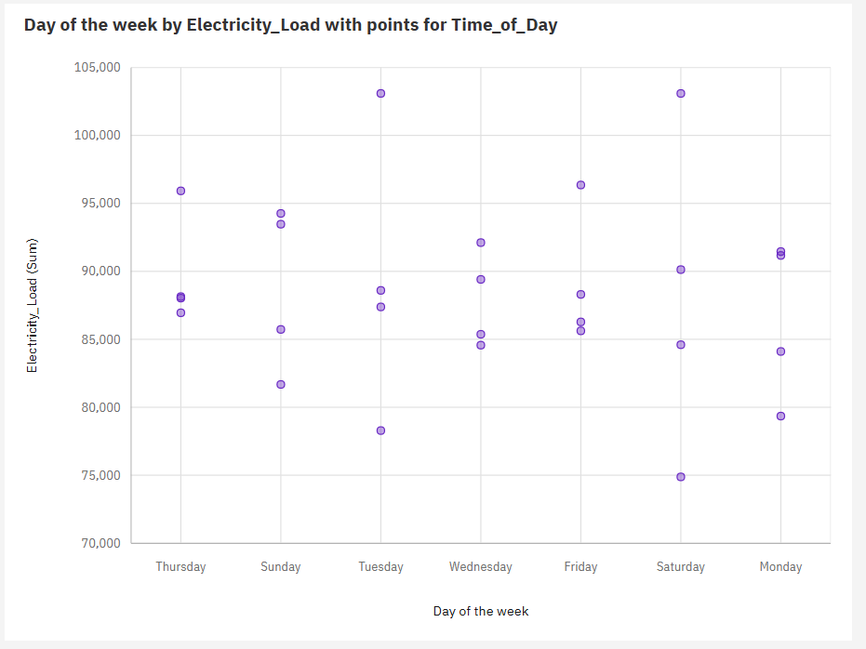

**Insights:**

* the sum of **Electricity Load** is nearly 2.5 million.
* **Electricity Load** ranges from almost 75 thousand, when **Day of the week** is Saturday, to over 103 thousand, when **Day of the week** is Tuesday.
* For **Electricity Load**, the most significant values of **Day of the week** are Thursday, Tuesday, Friday, Sunday, and Saturday, whose respective **Electricity Load** values add up to almost 1.8 million, or 71.9 % of the total.

**LINK:**<https://us1.ca.analytics.ibm.com/bi/?perspective=explore&pathRef=.my_folders%2Fmy%2Bnew%2Bexploration&subView=model0000018fd478f4d0_00000004>

**Visualization 8: PACKED BUBBLE**

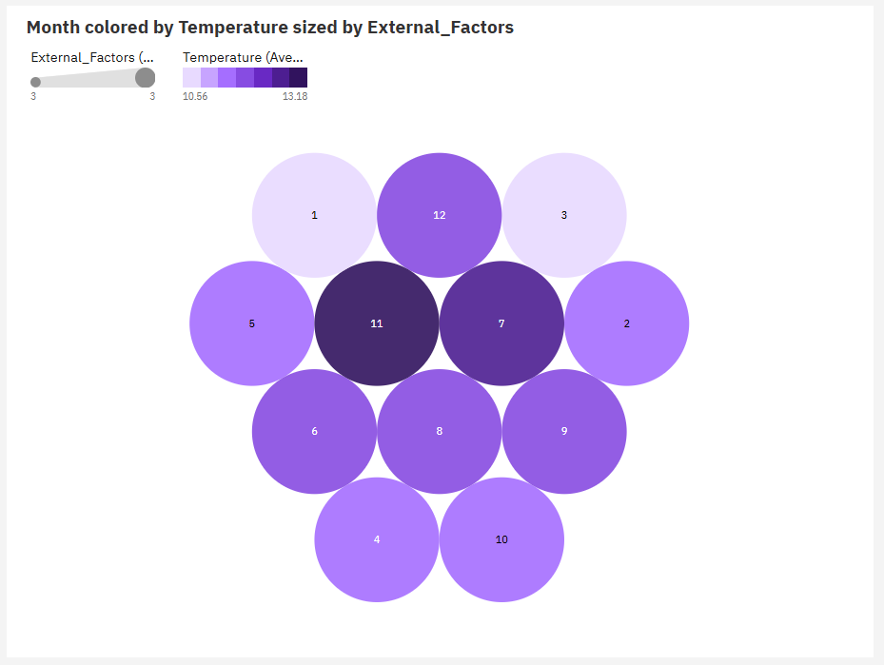

**Insights:**

* The overall number of results for **External Factors** is almost 3500.
* The overall number of results for **Temperature** is almost 3500.
* 1 is the most frequently occurring category of **Month** with a count of 309 items with **External Factors** values (9.3 % of the total).

**LINK:**<https://us1.ca.analytics.ibm.com/bi/?perspective=explore&pathRef=.my_folders%2Fmy%2Bnew%2Bexploration&subView=model0000018fd47ff24e_00000004>

**Visualization 9: HIERARCHICAL BUBBLE**

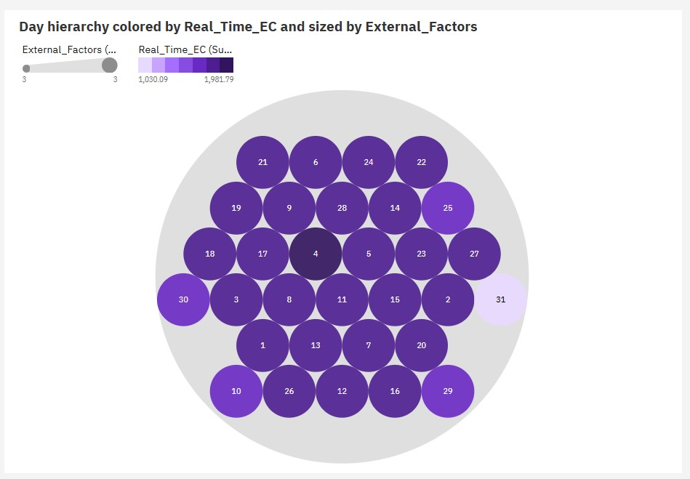

**Insights:**

* The overall number of results for **External Factors** is almost 3500.
* 22 (3.3 %), 23 (3.3 %), 24 (3.3 %), 25 (3.3 %), and 26 (3.3 %) are the most frequently occurring categories of **Day** with a combined count of 545 items with **External Factors** values (16.4 % of the total).

**LINK:**

<https://us1.ca.analytics.ibm.com/bi/?perspective=explore&pathRef=.my_folders%2Fmy%2Bnew%2Bexploration&subView=model0000018fd48fb9c3_00000004>

**Visualization 10: TREE MAP**

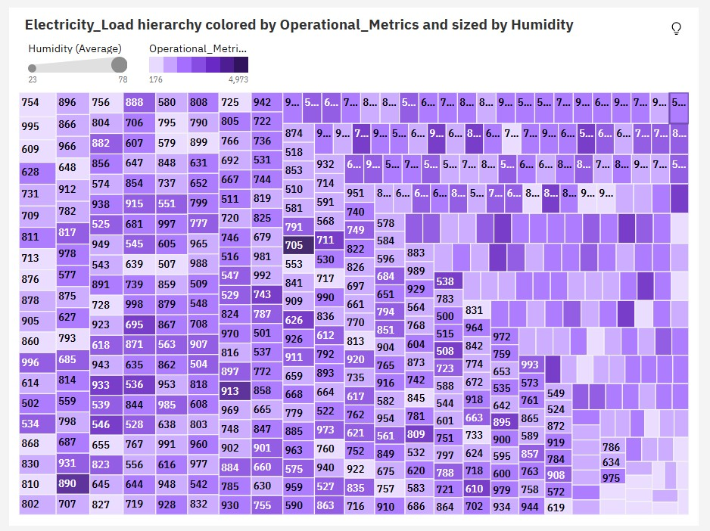

**Insights:**

* Over all values of **Electricity Load**, the average of **Humidity** is 49.24.
* The average values of **Humidity** range from 23, occurring when **Electricity Load** is 820, to 78, when **Electricity Load** is 754.

**LINK:**<https://us1.ca.analytics.ibm.com/bi/?perspective=explore&pathRef=.my_folders%2Fmy%2Bnew%2Bexploration&subView=model0000018fd90e681f_00000004>

**10.DASHBOARD CREATION:**

**INTRO PAGE SCREENSHOT:**



**INSIGHTS:**

**IoT Sensor Data:**

* Day of Week 1 has the lowest total IoT Sensor Data at 233.63, followed by 4 at 236.71.
* Day of Week 3 has the highest total IoT Sensor Data at 247.27, followed by 0 at 246.94.
* The overall number of results for IoT Sensor Data is almost 3500.

**Day Ahead Demand:**

* Day of Week 4 has the lowest total Day Ahead Demand at over 353 thousand, followed by 5 at almost 354 thousand.
* Day of Week 3 has the highest total Day Ahead Demand at over 357 thousand, followed by 2 at nearly 357 thousand.
* The overall number of results for Day Ahead Demand is almost 3500.

**Electricity Load:**

* Day of Week 0 has the lowest total Electricity Load at over 346 thousand, followed by 2 at over 351 thousand.
* Day of Week 3 has the highest total Electricity Load at over 359 thousand, followed by 1 at over 357 thousand.
* Based on the current forecasting, Electricity Load may reach nearly 359 thousand by Day of Week 8.
* The overall number of results for Electricity Load is almost 3500.

**LINK:** <https://us>1.ca.analytics.ibm.com/bi/?perspective=dashboard&pathRef=.my_folders%@FMY&action=view&mode=dashboard&subView=model0000018f8ce421ce_00000000

**DAY OF THE WEEK SCREENSHOT:**



**INSIGHTS:**

**Holiday Indicator and Temperature:**

* Day of the week FRIDAY has the highest Average Temperature but is ranked #6 in Average Humidity.
* Day of the week TUESDAY has the highest Average Humidity but is ranked #2 in Average Temperature.
* Overall day of the weeks, the average of Temperature is 11.83.
* The average values of Temperature range from 10.88, occurring when Day of the week is THURSDAY, to 12.5, when Day of the week is FRIDAY.

**IoT Sensor Data:**

* Day of the week THURSDAY has the highest Total IoT Sensor Data but is ranked #7 in Average Humidity.
* Day of the week TUESDAY has the highest Average Humidity but is ranked #6 in Total IoT Sensor Data.
* Overall day of the weeks, the average of IoT Sensor Data is 0.5097.

**Day Ahead LMP:**

* Day of the week TUESDAY has the highest Average Humidity but is ranked #7 in Total Day Ahead LMP.
* Day of the week MONDAY has the highest Total Day Ahead LMP but is ranked #5 in Average Humidity.
* Day Ahead LMP ranges from over 21 thousand, when Day of the week is TUESDAY, to almost 22 thousand, when Day of the week is MONDAY.

**LINK:** <https://us>1.ca.analytics.ibm.com/bi/?perspective=dashboard&pathRef=.my_folders%@FMY&action=view&mode=dashboard&subView=model0000018f8f5942f4_00000000

**TIME_OF_THE_DAY SCREENSHOT:**



**INSIGHTS:**

**Holiday Indicator:**

* Time of Day MORNING has the highest values of both Holiday Indicator and Temperature.
* Holiday Indicator ranges from 35, when Time of Day is AFTERNOON, to 47, when Time of Day is MORNING.
* Over all values of Time of Day, the sum of Holiday Indicator is 161

**Day Ahead Demand:**

* Time of Day AFTERNOON has the highest Average Humidity but is ranked #4 in Total Day Ahead Demand.
* Time of Day MORNING has the highest Total Day Ahead Demand but is ranked #4 in Average Humidity.
* The total number of results for Day Ahead Demand, across all Day Ahead Demand, is 4.

**Electricity Load and Previous Load:**

* Time of Day MORNING has the highest values of both Electricity Load and Previous Load.
* Over all values of Time of Day, the average of Electricity Load is 747.1.
* Over all values of Time of Day, the average of Previous Load is 751.7.
* The total number of results for Electricity Load, Previous Load across all Time of Day, is almost 3500.

**LINK:** <https://us>1.ca.analytics.ibm.com/bi/?perspective=dashboard&pathRef=.my_folders%@FMY&action=view&mode=dashboard&subView=model0000018f8f788389_00000000

**EXTERNAL FACTORS SCREENSHOT:**



**INSIGHTS:**

**Operational Metrics:**

* External Factors ECONOMIC has the highest values of both Operational Metrics and Humidity.
* The total number of results for External Factors, across all Operational Metrics, is 3.
* The total number of results for Operational Metrics, across all Operational Metrics, is 3.

**Temperature:**

* External Factors OTHER has the highest Average Temperature but is ranked #3 in Average Humidity.
* External Factors ECONOMIC has the highest Average Humidity but is ranked #2 in Average Temperature.
* REGULATORY (34.3 %) and ECONOMIC (34.2 %) are the most frequently occurring categories of External Factors with a combined count of 2,272 items with Temperature values (68.5 % of the total).
* Over all values of External Factors, the average of Temperature is 11.83.

**Day Ahead MLC:**

* Day_Ahead_MLC is unusually low when External Factors is OTHER.
* External Factors ECONOMIC has the highest Average Humidity but is ranked #2 in Total Day_Ahead_MLC.
* External Factors REGULATORY has the highest Total Day_Ahead_MLC but is ranked #2 in Average Humidity.

**LINK:**

<https://us>1.ca.analytics.ibm.com/bi/?perspective=dashboard&pathRef=.my_folders%@FMY&action=view&mode=dashboard&subView=model0000018f8fb2319b_00000000

**11.REPORT CREATION:**

**LINK:**

[**https://us1.ca.analytics.ibm.com/bi/?pathRef=.my_folders%2FNEW%2BREPORT&action=edit**](https://us1.ca.analytics.ibm.com/bi/?pathRef=.my_folders%2FNEW%2BREPORT&action=edit)

**REPORT VISUALIZATION SCREENSHOT:**

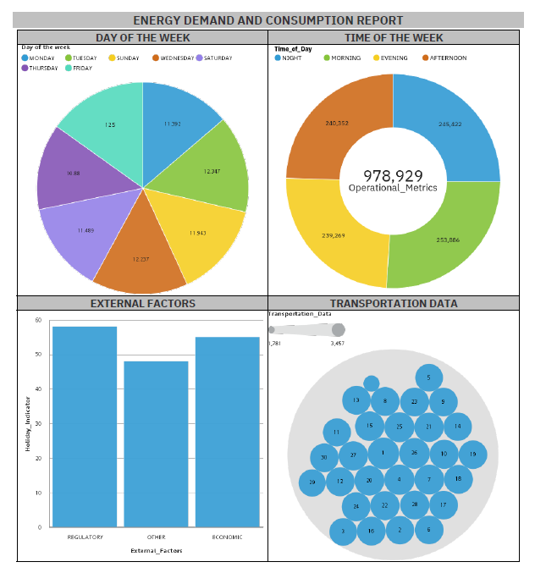

**REPORT LIST PAGE SCREENSHOT:**

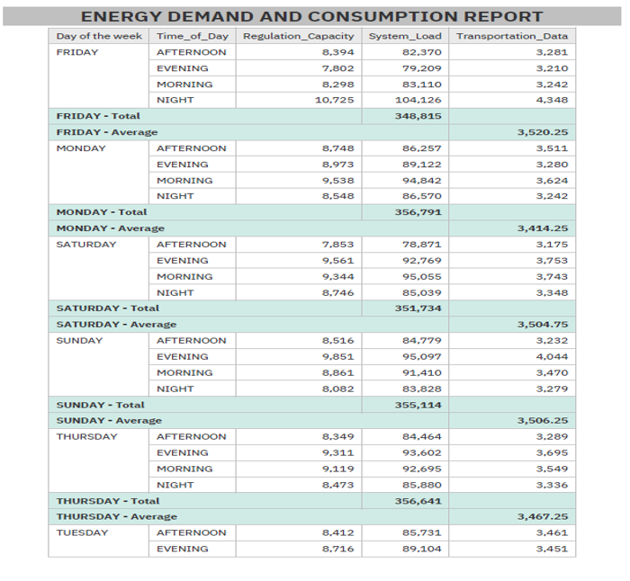

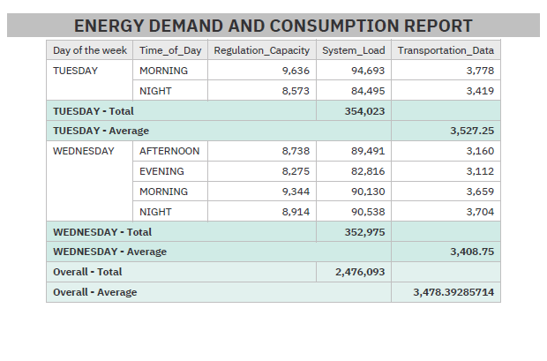

**PDF DRIVE LINK:**

[https://drive.google.com/file/d/1dzZZT5rOqzShoi3Yzbk2VY9Dcy4YCNYd/view?usp=drivesdk](https://drive.google.com/file/d/1dzZZT5rOqzShoi3yZBK2VY9Dcy4YCNYd/view?usp=drivesdk)

**12.STORY CREATION:**

**LINK:** [**https://us1.ca.analytics.ibm.com/bi/?perspective=story&pathRef=.my_folders%2Fnew%2Bstory&action=view&sceneId=model0000018fd9870c1c_00000005&sceneTime=5000**](https://us1.ca.analytics.ibm.com/bi/?perspective=story&pathRef=.my_folders%2FNew%2Bstory&action=view&sceneId=model0000018fd9870c1c_00000005&sceneTime=5000)

**PDF DRIVE LINK:**

[**https://drive.google.com/file/d/1dweZ-GzaLlm9IcyVdJVteif03k13GcWQ/view?usp=drivesdk**](https://drive.google.com/file/d/1dweZ-GZaLlm9IcyVdJVteif03k13GcWQ/view?usp=drivesdk)

**SCREENSHOTS:**

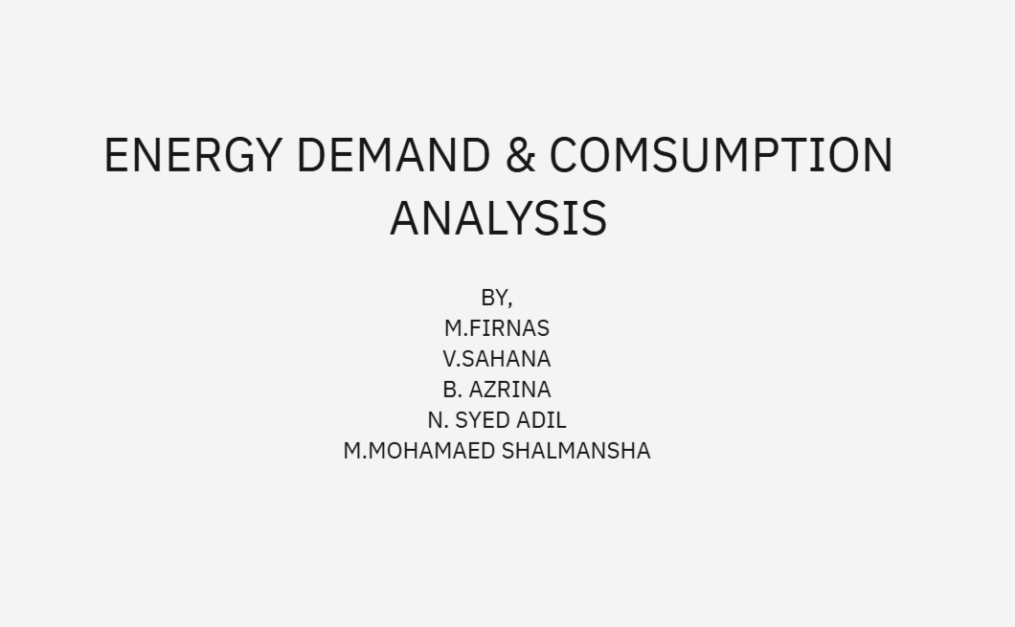

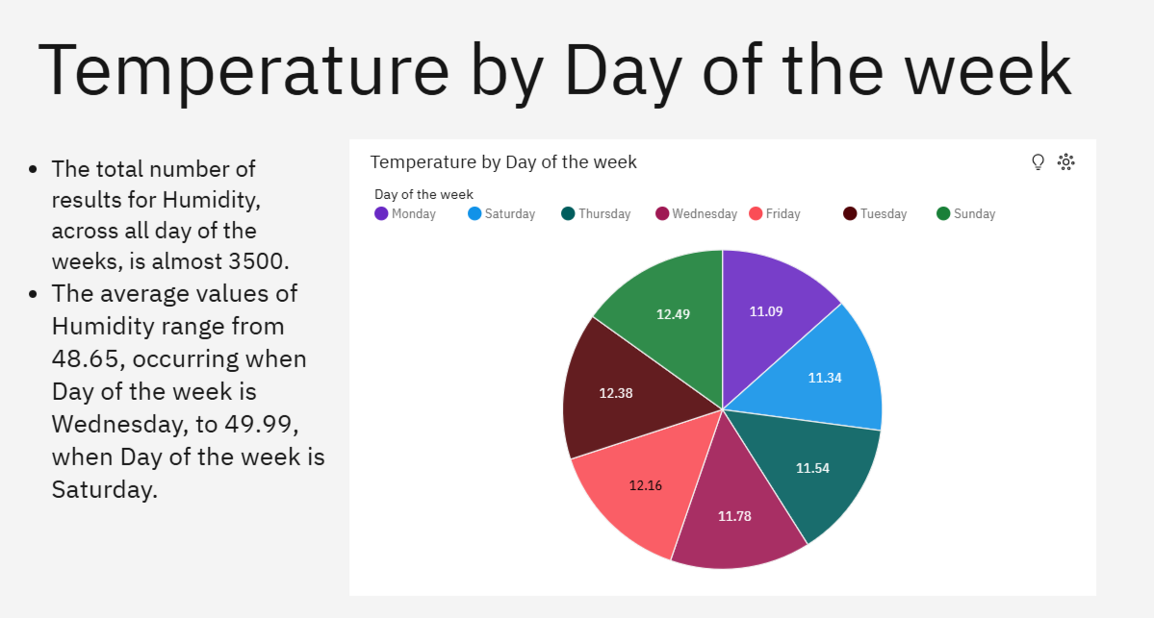

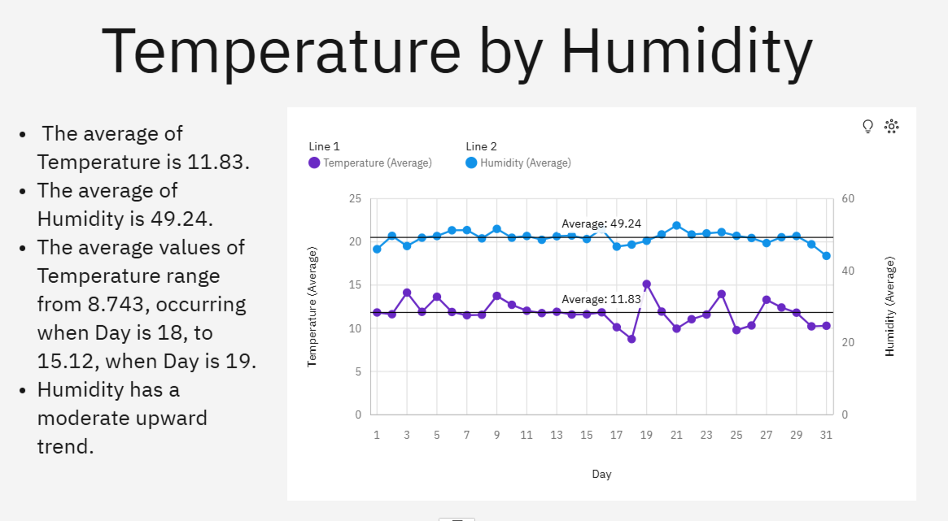

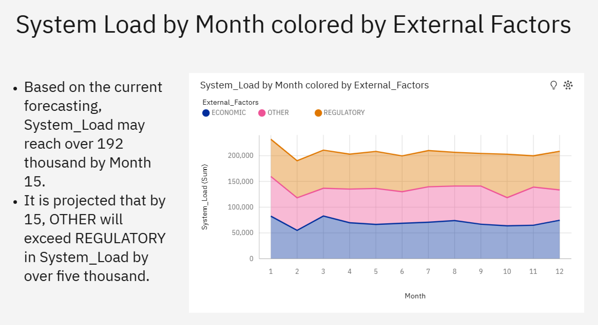

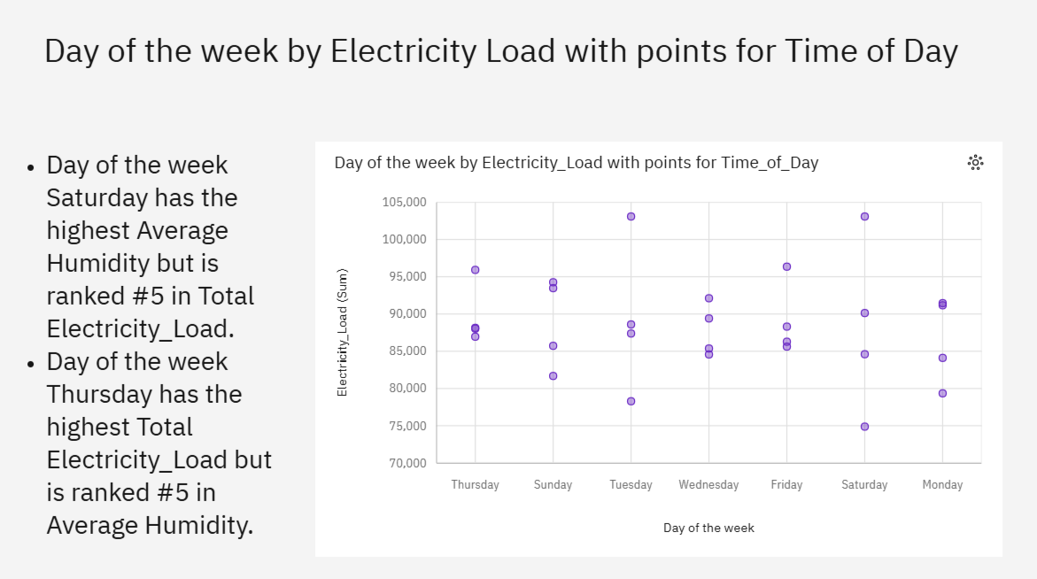

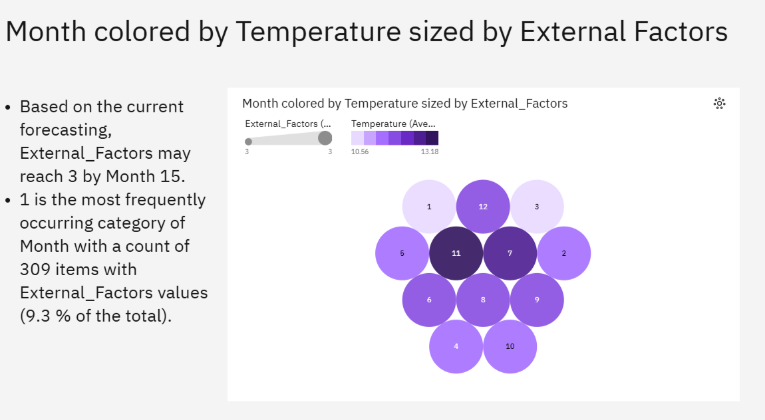

**13.DESCRIPTIVE ANALYSIS:**

The dataset is a comprehensive collection of data points related to electricity load, environmental conditions, time-based categorizations, operational metrics, IoT sensor data, and financial market information. This project focused on energy demand and consumption. Analysis of how electricity load varies across different times of the day and days of the week. Peak demand times and low consumption periods can be identified. Correlation between load and environmental factors like temperature and humidity. Comparison of electricity load on holidays versus regular days, revealing consumption patterns affected by holidays. Understanding how various operational and transportation metrics impact electricity consumption and identifying periods of operational efficiency. Study of how real-time and day-ahead electricity prices (LMP) fluctuate with changes in load. This can help in understanding the financial aspects of electricity consumption. Breakdown and analysis of different cost components to understand their influence on overall electricity expenses. Building models to predict future electricity load based on historical data and various influencing factors Exploring correlations between electricity load and other variables like temperature, humidity, operational metrics, and financial data to identify key drivers of electricity consumption. Visualize electricity load, temperature, and humidity over time to observe trends, seasonality, and anomalies Explore relationships between electricity load and other numerical features such as temperature, humidity, and LMP. By leveraging this data, one can gain valuable insights into temporal trends, environmental impacts, operational efficiency, and market dynamics, enabling better energy management and decision-making processes.

**14.PREDICTIVE ANALYSIS:**

Predictive analysis involves using historical data to make informed predictions about future outcomes. In this context, we aim to predict the future electricity load based on various influencing factors present in the dataset. By leveraging historical data on electricity consumption along with a variety of influencing factors such as temperature, humidity, day of the week, time of day, and operational metrics, predictive models can be developed to forecast future electricity load with a high degree of accuracy. Machine learning techniques like linear regression, time series analysis, and advanced algorithms such as ARIMA, LSTM (Long Short-Term Memory), and random forests can be employed to capture the temporal dependencies and complex relationships within the data.

In addition to environmental factors, incorporating financial and market data such as real-time and day-ahead locational marginal prices (LMP) and various cost components can enhance the model’s predictive power by accounting for economic influences on load patterns. The holiday indicator and external factors further refine the model by incorporating variations due to special events and other external conditions. The inclusion of previous load data adds another layer of context, enabling models to account for inertia and recent trends in electricity consumption.

Through predictive analysis, utility companies can optimize energy distribution, better manage resources, and anticipate peak demand periods, leading to improved efficiency and reliability in the power grid. Moreover, accurate load forecasting helps in strategic planning, reducing operational costs, and ensuring a stable supply of electricity. Overall, predictive analysis using this dataset provides a robust foundation for making data-driven decisions in energy management and planning.

**15.ACTION PLAN:**

1. **Feature Engineering**:

* Identify relevant features (columns) for our analysis.
* Create new features if necessary (e.g., aggregations, transformations).

1. **Time-Series Analysis**:

* Since the dataset contains timestamps, we can explore trends over time.
* Calculate summary statistics (mean, median, standard deviation) for each time period (e.g., day, week, month).
* Visualize the load data over time using line plots or bar charts.

1. **Load Profile Segmentation**:

* Group the data by load type (e.g., “Regulatory,” “Economic,” “Other”).
* Calculate load profiles (average load values) for each load type.
* Compare load profiles to identify patterns and differences.

1. **Energy Demand Optimization Strategies**:

* Load shifting: Encourage users to shift energy-intensive tasks to off-peak hours.
* Demand response: Implement programs to reduce load during peak times.
* Energy-efficient practices: Promote energy-saving behaviours.
* Renewable energy integration: Explore options for using renewable sources.

**16.CONCLUSION:**

In conclusion, optimizing energy demand and consumption through data-drive strategies represents a crucial pathway towards achieving greater efficiency, sustainability, and resilience in our energy systems. By harnessing the power of data analytics, machine learning, and predictive modelling, researchers and practitioners can develop innovative solutions to address the complex challenges of energy management. Key works in this field highlight the importance of advanced data analytics techniques, integration of renewable energy sources, smart grid technologies, behavioural analytics, and policy frameworks. The adoption of data-driven strategies for optimizing energy demand and consumption is a strategic necessity for organizations aiming for sustainability and efficiency. The insights provided by our dashboard demonstrate the transformative potential of data in driving smarter, more sustainable energy practices. Continuous innovation and investment in data analytics will be crucial for sustaining and enhancing these benefits, ensuring a resilient and energy-efficient future.